Goals

To be able to:
- Launch JUnit tests as part of an EclEmma coverage analysis session.
- Interpret EclEmma coverage highlighting with respect to the: (a) class under test, and (b) overall project structure.
- Remove EclEmma coverage sessions.

Steps

- Launch Eclipse and Create a New UnitTestDemo2 Project
  - In Windows, Click Start → Programs → Developer Tools → Eclipse
  - From the Top Menu Bar, Click File → New → Project
  - Select 'Java Project' and Click 'Next'
  - For the Project Name, enter 'UnitTestDemo2'
  - In Contents, Select 'Create project from existing source'
  - For the directory, Click Browse and select the 'UnitTestDemo2' folder
Note: Your presenter will provide you with the path to the directory.
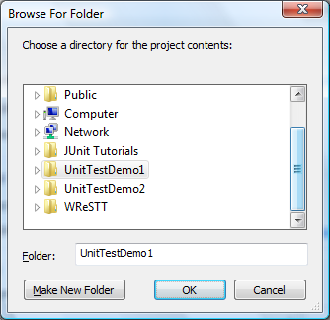
  - Click OK, and then Click Finish
Note: In the Package Explorer (left pane) you should now see the project.

- Run a JUnit Test in Coverage Mode
  - Right Click “MyBankAccountTest.java” (from the UnitTestDemo1 Project), Select 'Coverage As → JUnit Test
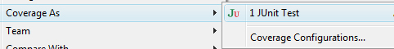

  - Double Click “BankAccount.java” to view highlighting for class
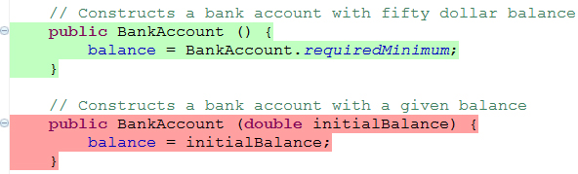
Note: Green Highlight – Executed Instruction, Red – Missed Instruction.

- Analyze Coverage of Elements of the UnitTestDemo1 Project
  - In the Coverage Tab (bottom pane), expand the UnitTestDemo1 Project.
  - Observe the percentage of the packages and classes covered, including number of covered instructions vs. total instructions.

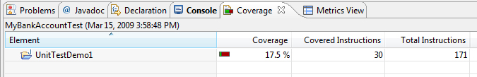
  - Clear all coverage sessions by clicking on the Remove All Sessions button at the far right of the Coverage Tab.
  - Open “BankAccountTest.java” (from the UnitTestDemo1 Project) and look at the tests that have been implemented.
  - Run this test in coverage mode, and observe how the coverage of the project structure compares to your previous run of MyBankAccountTest.java.

- Compare Element Coverage of UnitTestDemo1 and UnitTestDemo2
  - Ensure that all coverage sessions have been cleared by clicking on the Remove All Sessions button at the far right of the coverage tab.
  - Right Click “BankAccountTest.java” from the UnitTestDemo1 Project, select 'Coverage As → JUnit Test
  - Right Click “BankAccountTest.java” from the UnitTestDemo2 Project, select 'Coverage As → JUnit Test
  - Use the Select Session Button at the far right of the coverage tab to switch between the coverage sessions for UnitTestDemo1 and UnitTestDemo2 to compare their coverage results.

