Lab 1: Open a browser and go to Google

Goal: Be able to open a browser and navigate it to a particular site

Specific objectives
- Create a new test in fitnesse
- Create an instance of the Internet Explorer browser
- Navigate it to www.google.com

Steps
- Open your fitnesse homepage
  - The instructor will provide the URL
- Create a new test called TestLab
  - Click Edit on the left hand side
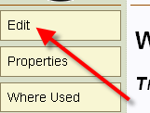
  - At the bottom of the editable text area add “^TestLab”
  - Click Save
- Go into the new test
  - Click on the ‘?’ after the test name
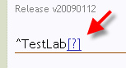
  - This will bring you to your new test
- Add the Import statements so SWAT can run correctly
  - Remove any text already in the edit box (if it exists)
  - Add the import statements
    - !|Import|
|SWAT.Fitnesse|
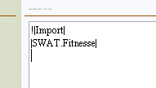
- Add an instance of a browser
  - Leave a blank line after import statements
  - Add
    - !|InternetExplorerSWATFixture|
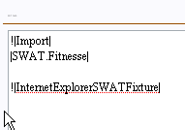
- Add the statements to open and navigate the browser
  - Leave a blank line after import statements
  - Create a new Test Block
    - !|SWATFixture|
  - Add the open browser statement
    - |OpenBrowser|
  - Add the navigate statemenent
    - |NavigateBrowser|url|
      - URL - www.google.com
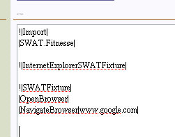
- Save and run the test
  - Click Save
  - On the left hand side, press the Test button
    - Note if Test button does not show up click on Properties and select the Test attribute
  - 