An IBM Proof of Technology
Rational Functional Tester

Lab Exercises

© Copyright International Business Machines Corporation 2007, 2008,2009. All rights reserved.
US Government Users Restricted Rights - Use, duplication or disclosure restricted by GSA ADP Schedule Contract with IBM Corp.
Contents
Overview 3
Introduction 3
Lab 1 Automating Tests Using Rational Functional Tester 5
1.1 Lab Overview 5
1.2 Rational Functional Tester Benefits 5
1.3 Introduction to the application under test and test scenario. 6
Lab 2 Play Back Test 31
Lab 3 Record Test 33
Lab 4 Play Back Test 42
Appendix A. IBM TechWorks 44
Appendix B. Notices 45
Appendix C. Trademarks and copyrights 47

THIS PAGE INTENTIONALLY LEFT BLANK

Overview
In this Proof of Technology (PoT), the participants will learn how to:
- Use best practices and tools to keep your testing teams aligned with business priorities
- Reduce rework costs by finding defects and architectural flaws early
- Leverage distributed or outsourced testing teams without compromising schedules, processes, or the flow of information
- Speed testing by automating code, build validation, unit, functional, security and system testing
- Minimize hardware costs and ensure system scalability through rigorous load and performance testing
- Integrate development, test and IT operations for improved IT life cycle management
- Get the right information fast to make informed “go or no-go” decisions
This PoT will provide detail and/or demonstrations of:
- IBM® Rational® Functional Tester

Introduction
As a Quality Assurance/Testing professional it is your job to uncover bugs and ensure that systems perform as expected. There are more obstacles today then ever before when testing. Whether it is new technology, new business demands, broader teams, or any of the many other challenges you are dealing with, we understand your testing projects are more complex, harder to manage and expect more of you than ever before.
Why choose IBM Rational Quality Management solutions? Make confident go/no go decisions with:
- Single integrated software quality management platform for improved reliability, predictability and team efficiency across the software lifecycle
- Superior functional testing with test automation and data sharing for streamlined, efficient test execution
- Integrated traceability of business, functional requirements, use cases, and SLAs for accurate test case planning
- More thorough performance testing both pre and post deployment for reduced system downtime
- Integrated web application security and compliance testing
- Wide range of platform and application support including Web, Java™, Web services, J2EE, .Net, SAP, Siebel, Oracle and IBM mainframes
At Rational we understand that it takes a combination of automated testing and manual testing coupled with good test management and best practices to be successful.

The following symbols appear in this document at places where additional guidance is available.
Icon | Purpose | Explanation
 | Important! | This symbol calls attention to a particular step or command. For example, it might alert you to type a command carefully because it is case sensitive.
 | Information | This symbol indicates information that might not be necessary to complete a step, but is helpful or good to know.
 | Trouble-shooting | This symbol indicates that you can fix a specific problem by completing the associated troubleshooting information.

- Automating Tests Using Rational Functional Tester
This lab provides a brief introduction to the capabilities of IBM Rational Functional Tester (RFT).
The key capabilities discussed in this exercise are:
- Building an automated test script
  - Recording process
  - Wizard to create a data-driven test
  - Verification Points wizards to insert tests to validate application behavior
  - Regular Expressions to test dynamic data
- Executing the script
  - Lab Overview
In today’s complex applications there are multiple challenges in automating testing. Some of these are:
- Control cost of test automation
  - Inexperienced testers face steep learning curve for tools
  - Test maintenance grows with project
- Testing Tools Lack Flexibility
  - Power users hands are tied by tool limitations
- Test Team Integration
  - Managing script changes with parallel development
  - Sharing test assets with the larger software team
  - Rational Functional Tester Benefits
Capabilities Highlighted:
- Benefits of test automation to validate proper business use case of application
  - Speed of test execution
  - Accuracy of test execution (repeatability)
  - Effective communication with other project team members
- Benefits of Rational’s test automation solution
  - Simple test script recording with wizards to help build complex tests
  - Use of standard IDE’s to provide robust script development, debugging and a shared IDE with development
  - Choice of Java or VB.net to develop in a language most familiar to testers and shared with the development team
  - Robust test scheduling and execution
  - Intuitive test results display

Important!
If you encounter problems during the course of this exercise, please contact the class instructor or any of the lab assistants.

This lab is intended to be completed in 60 minutes.

  - Introduction to the application under test and test scenario.
Classics Java is a Java application that allows registered users to buy cd’s and the administrator can run inventory reports and add items. In past releases, this application has been manually tested by a team of testers and analysts who used Microsoft Excel and Microsoft Word to document tests and analyze test results.
The testing team has been wrestling with incomplete and inaccurate testing, difficulty keeping the test documentation up to date with incomplete and inaccurate testing, difficulty in analyzing test results. To alleviate some of these problems, the project team has recently adopted the Quality Management Solution of IBM Rational.
Now, our project team has been building automated tests for the Classics application.
In this lab we will create automated tests for the following use cases:
- Order a CD for an existing customer
- Order a CD for a new customer
- Perform an administrative function

- Start Rational Functional Tester
  - Select Start→Programs→IBM Software Delivery Platform→IBM Rational Functional Tester→Java Scripting
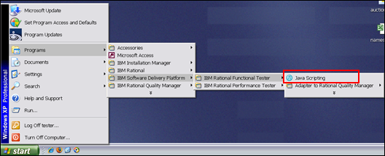
- Keep default workspace and select OK button
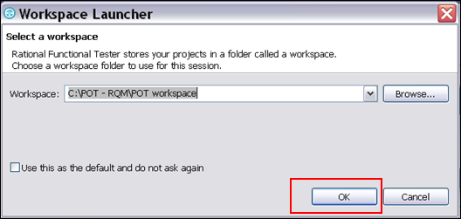
- Review Rational Functional Tester
Rational Functional Tester is based on Eclipse and can use either Java or VB.Net as the scripting language. For this lab we are using the Java version.
Tests are organized into Test Projects. This example has two projects Auction and Classics. We will be using the Classics project for this lab.
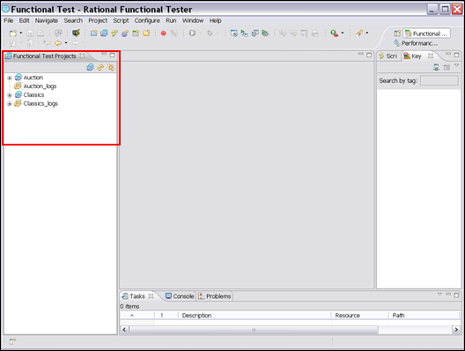
If you see this error window please select Ignore button
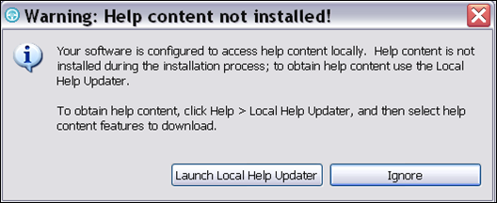
- Expand the Classics Project by selecting the + sign
We can see that a number of tests have already been recorded for the classics application. There is also a logs folder which is where the execution results for the tests are organized.
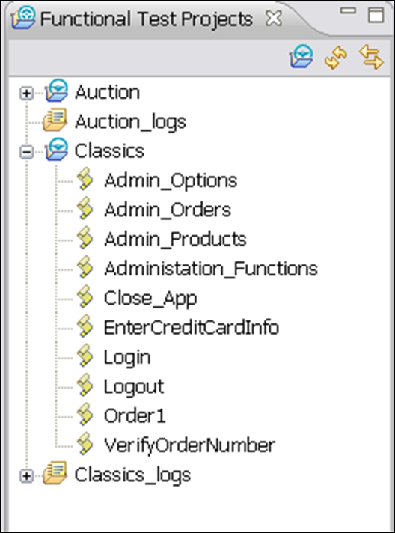
- Select the Record button in the toolbar
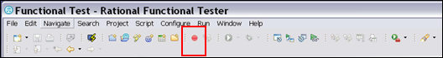
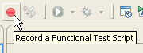
- Select Classics Project, enter Script Name: Order_existing_customer and Select Finish Button
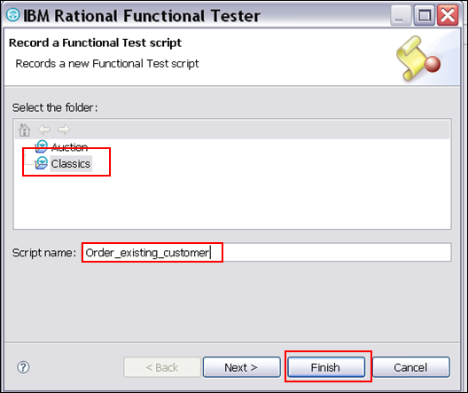
- Review Recording Wizard
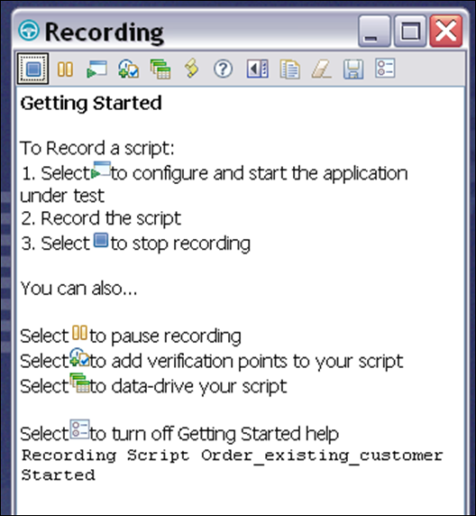
Important!
Once you select to start the application and you see the Classics application open, the recorder is recording every mouse click and interaction with the window. Please follow instructions exactly so your script matched the screen shots.
If you accidentally miss a step please pause and let the instructor know.

- Select Start Application icon in toolbar
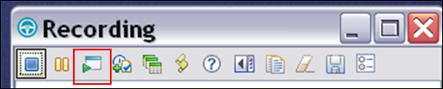
Important!
Once you select to start the application and you see the Classics application open, the recorder is recording every mouse click and interaction with the window. Please follow instructions exactly so your script matched the screen shots.
If you accidentally miss a step please pause and let the instructor know.
- Select Application name ClassicsJavaA-java and select OK button
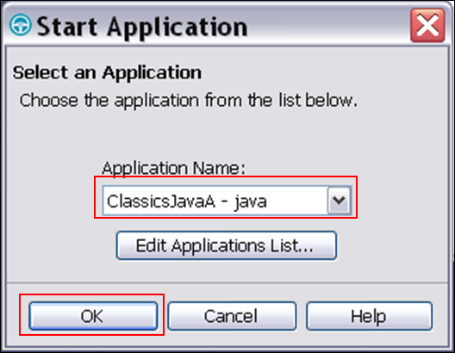
- Select Place Order button
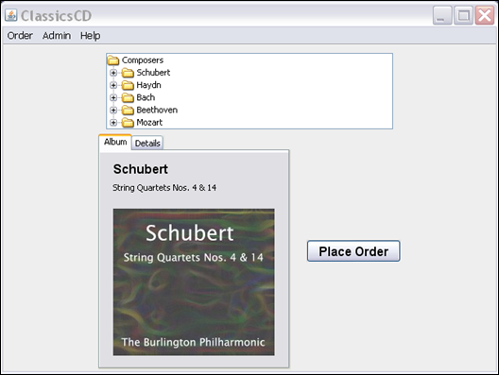
- Verify certain items on Member Logon Window
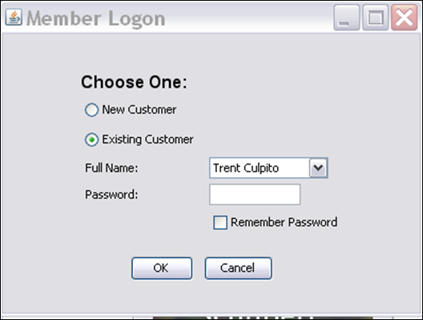
- Verify correct default radio button is selected
  - Select Insert Verification Point icon in toolbar
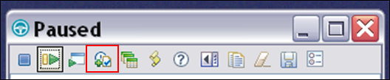
Verification points are checkpoints in the test that validate a specific behavior of the application under test.

  - Click on the Object Finder: hand icon and holding it down drag it over the item we want to verify the radio button:Existing Customer
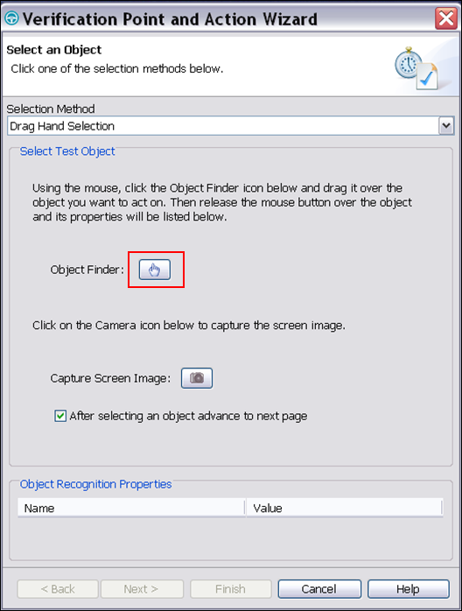
  - Holding the left mouse down move the hand over the Existing Customer radio button until you see the red box around the object and release the left mouse button
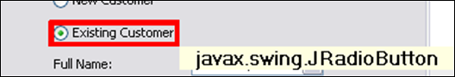
  - Select the radio button Perform Properties verification Point and select Next>
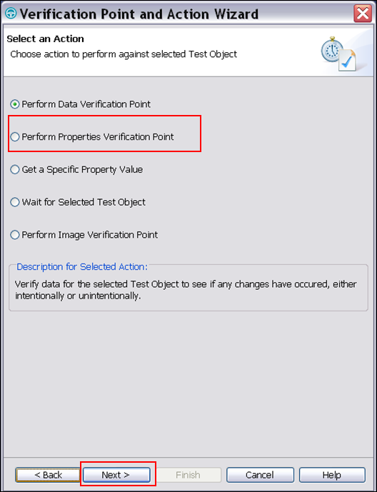

  - Rename VP: ExistingCustomerRadioButton and Select Next button
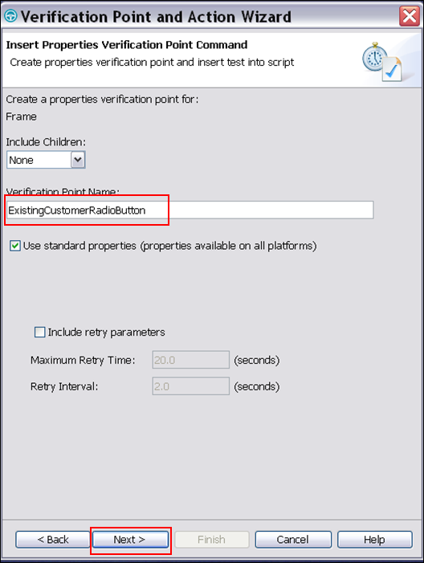
  - Check the state Enabled and Select Finish button
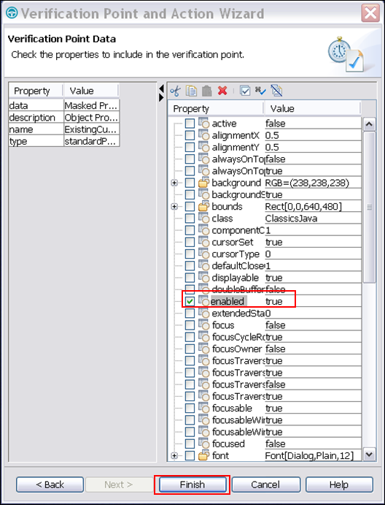
  - The test detail is shown in the wizard as you record
We can see the verification point ExistingCustomerRadioButton has been inserted into the test script
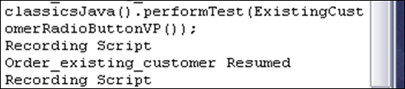
- Verify the data contents of the drop down list box
  - Select Insert Verification Point icon in toolbar
  - Click on the Object Finder: hand icon and holding it down drag it over the item we want to verify the Full Name
- Highlight the Full Name Trent Culpito
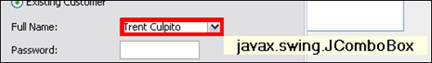
- Select Perform Data Verification Point and select Next button
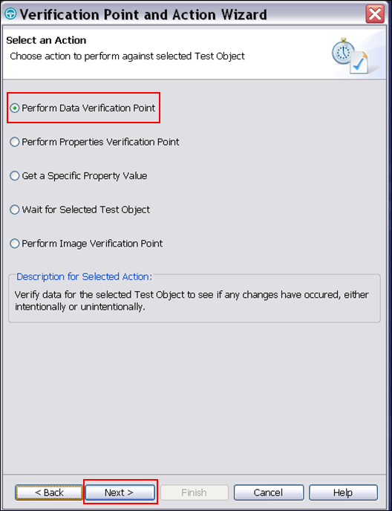

- Enter VP name FullName and select Next> button
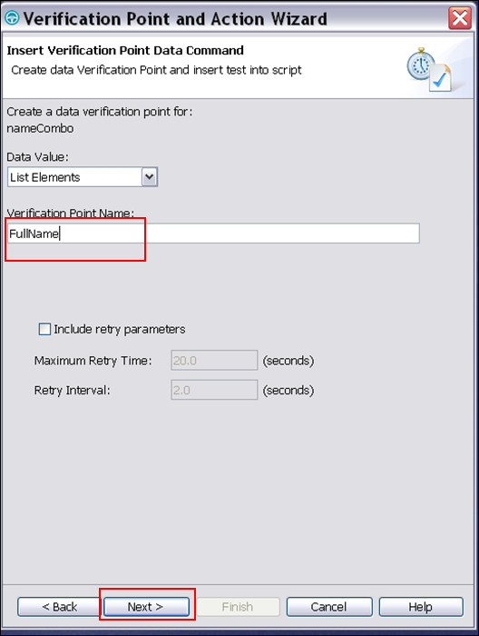
- Verify data in list and select Finish Button
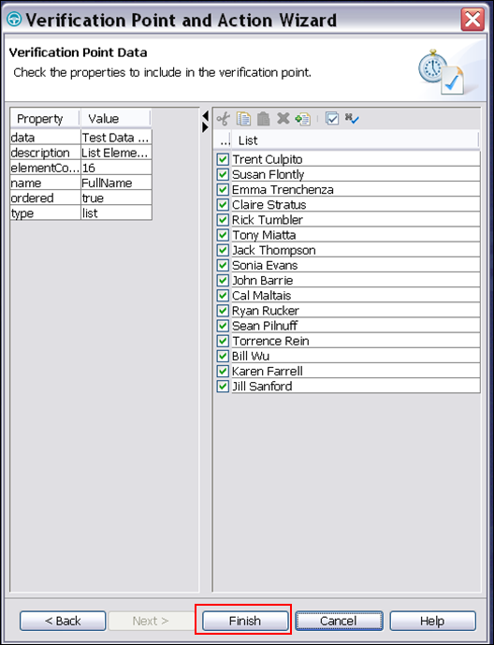
- Select OK button
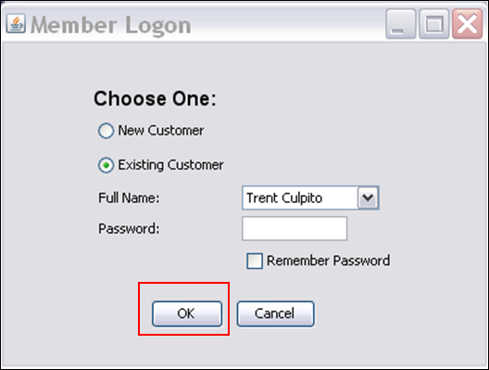
- Place an Order window displays
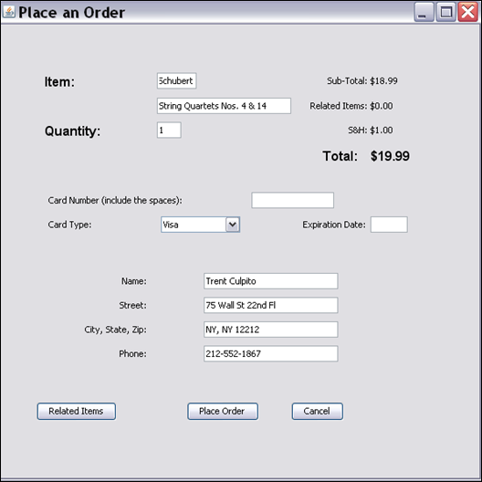
- Enter Order Information
  - Card Number : 123412341234
  - Expiration Date: 1/10
  - Select Place Order button
- Verify Confirmation Window
  - Select Insert Verification Point icon in toolbar
  - Click on the Object Finder: hand icon and holding it down drag it over the item we want to verify the order confirmation window
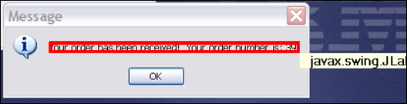
- Select Perform Data verification Point radio button and select Next> button
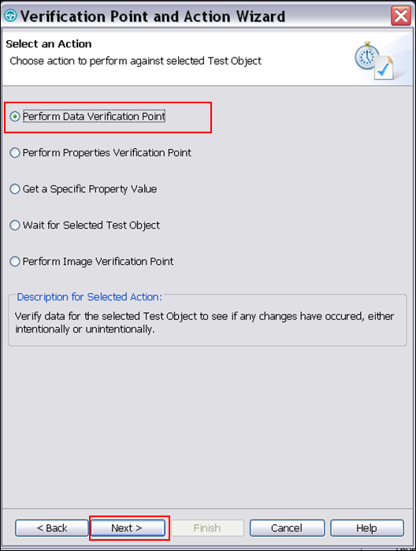
- Enter VP Name: OrderConfirmation and Select Next> button
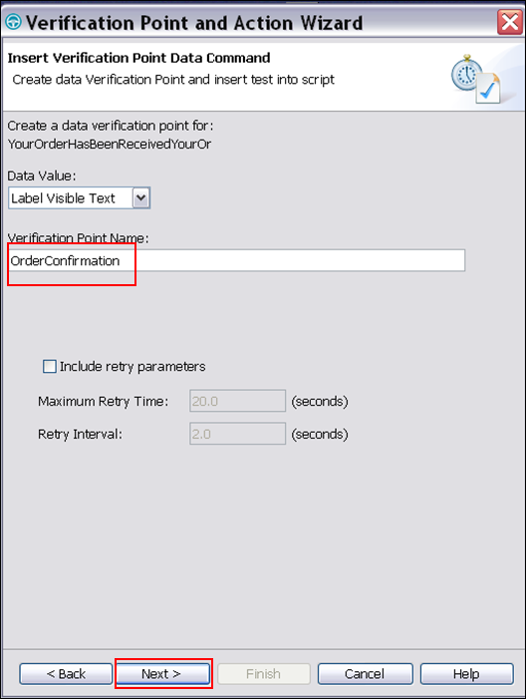
- Convert to regular expression
When creating a dataverification point you need to consider if any of the data will be variable. When playing back this test the verification point will always expect the exact same data that is saved off.
In this example we know the order number will be different every time. To avoid false failures we can change the part of the string that has the order number to use a regular expression.
The example below will verify that everything up to the number is expected to be the same
  - Select Convert to regular expression toolbar button
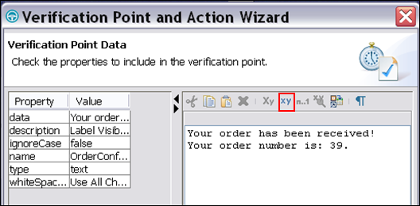
- Replace the ordered 39(or whatever numeric value you see there) with * and Select Evaluate Regular expression toolbar button
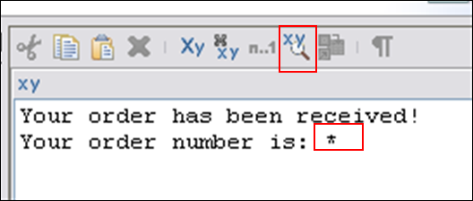

- Select Evaluate button and see Result is MATCH
This is a simple example of a regular expression ie wildcard *.. if you were using a more complicated regular expression you could use the evaluator to ensure that you are entering the correct regular expression pattern
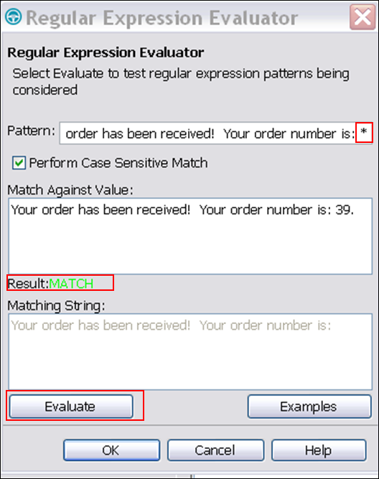
- Select OK button
- Select Finish button
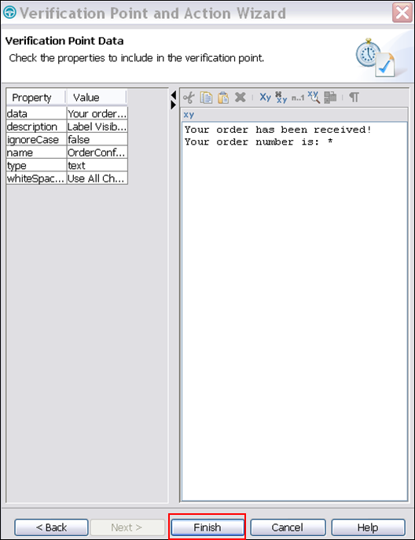
- Select OK button
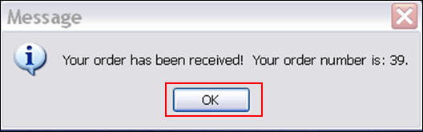
- Close Classics CD application
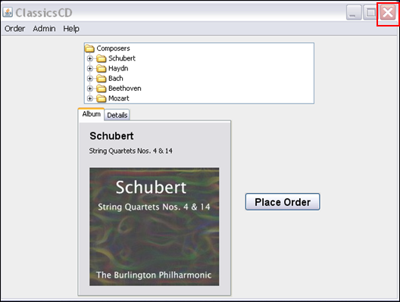
- Select Stop Recording icon from toolbar
- Review test script
Rational Functional Tester uses Java or VS.net for test script development. This provides an powerful editor which for some of you, will be the same environment and language (Java or VB.net) that your developers are using to write the application. Sharing a common IDE and language allows testers and developers to collaborate on their work. For example, developers can easily run these functional tests directly from within their IDE. Additionally, testers can leverage the developer’s language knowledge to write custom extensions for the test script.
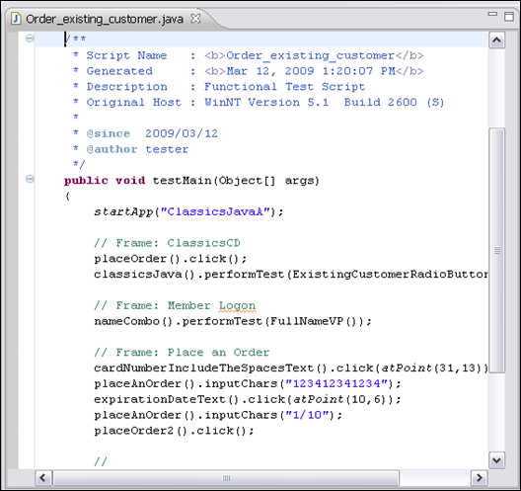
- Locate the script explorer tab on the right hand side
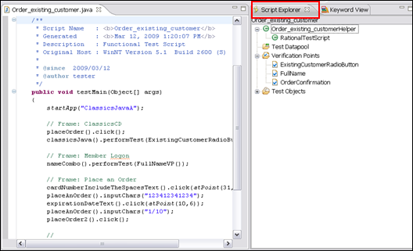
The Script Explorer organizes the Datapools, Verification Points and Object Map. The tester can quickly modify any of these items directly from this explorer view.
- Close test script and if prompted save edits by selecting OK
- Play Back Test
- Select the Playback button from the toolbar
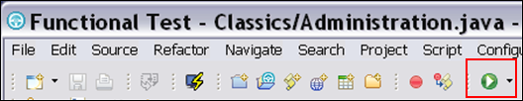
- Select order_existing_customer and select Finish button 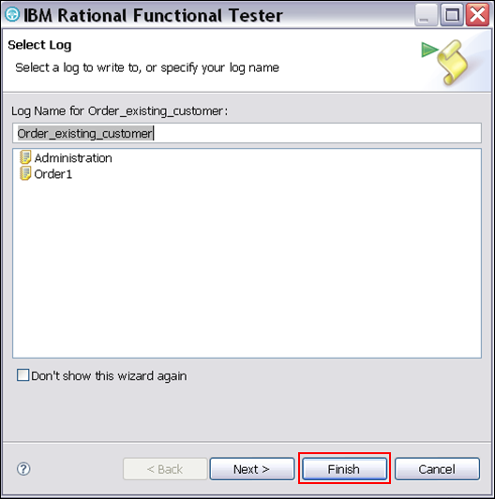
- The test will begin playing back……Do not touch window during playback let test complete. A test log will display when complete
- Review Test Log
A log is shown with the results. As expected everything passes. If there was a failure you could select the View Results link (see an example under the Verification Point – ExistingCustomerRadioButton) and you would be shown the expected result saved during recording and the expected during playback.
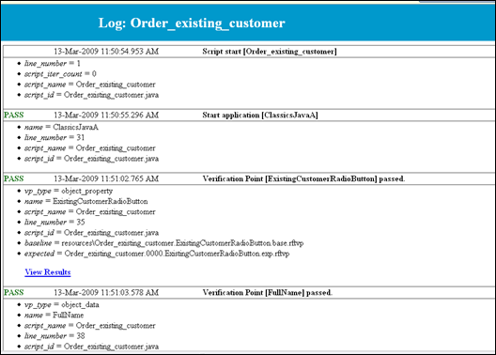
- Record Test
- Select the Record button in the toolbar
- Select Classics Project, enter Script Name: Administration and Select Finish Button
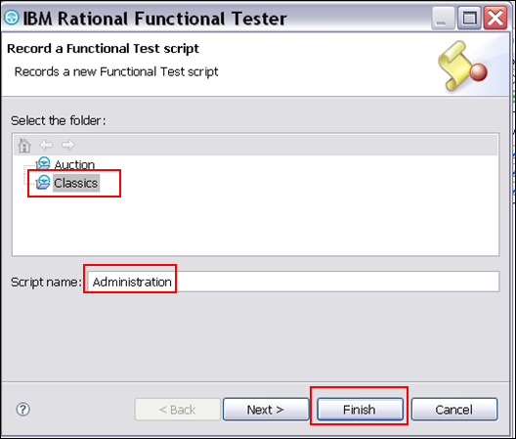
- Review Recording Wizard
Important!
Once you select to start the application and you see the Classics application open, the recorder is recording every mouse click and interaction with the window. Please follow instructions exactly so your script matched the screen shots.
If you accidentally miss a step please pause and let the instructor know.

- Select Start Application icon in toolbar
Important!
Once you select to start the application and you see the Classics application open, the recorder is recording every mouse click and interaction with the window. Please follow instructions exactly so your script matched the screen shots.
If you accidentally miss a step please pause and let the instructor know.
- Select Application name ClassicsJavaA-java and select OK button
- Select Admin→Orders
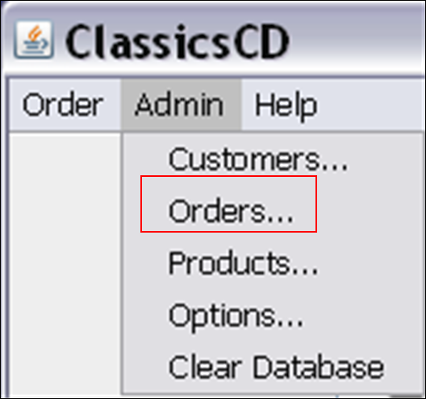
- Enter Password: Administrator and select OK button
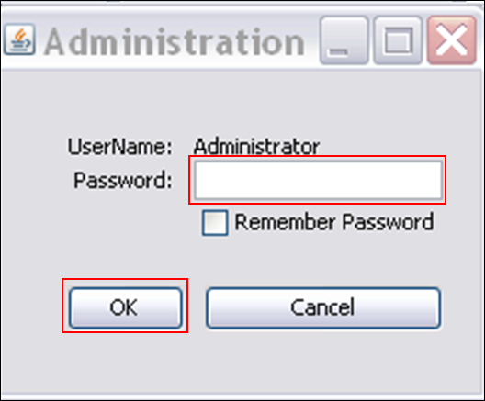
- Select Insert Verification Point icon in toolbar
- Click on the Object Finder: hand icon and holding it down drag it over the item we want to verify the order window
When you move the object finder hand over different objects you will see the object highlighted and red and the object type.
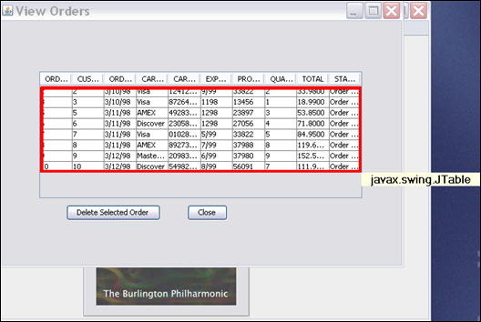
- Select Perform Data verification Point radio button and select Next>
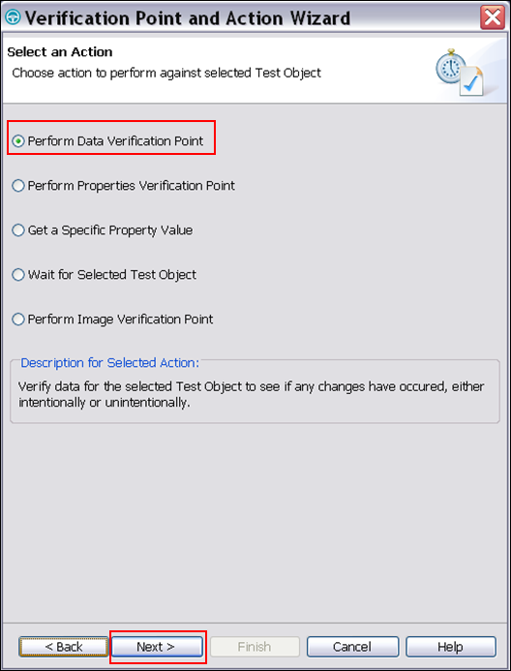
- Select Table Contents and select Next> button
The Table Contents will select all the rows of the table.
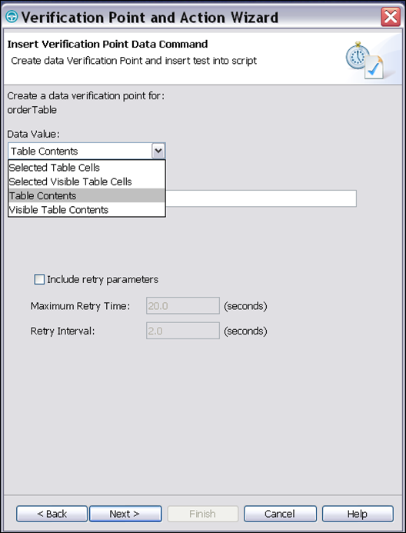
- Expand window to see all data columns, Review the data captured and select Finish button
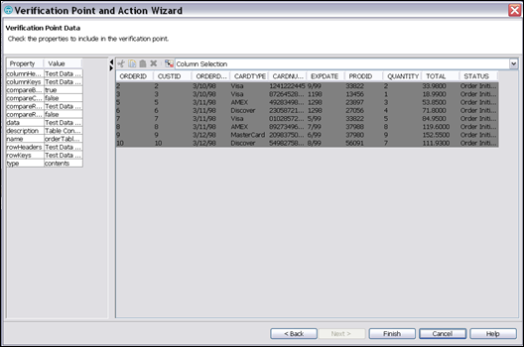
- Select Close
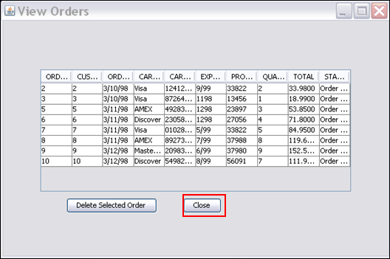
- Close Classics Java App
- Review Test
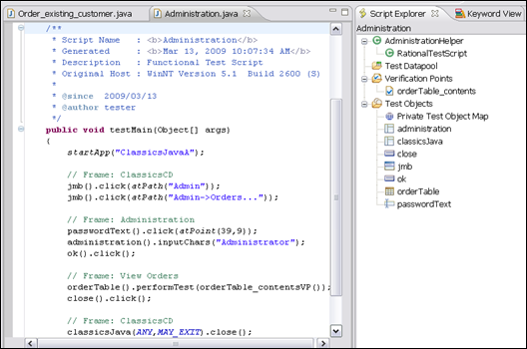
- Play Back Test
- Select Playback button
- Select Administration and select Finish button
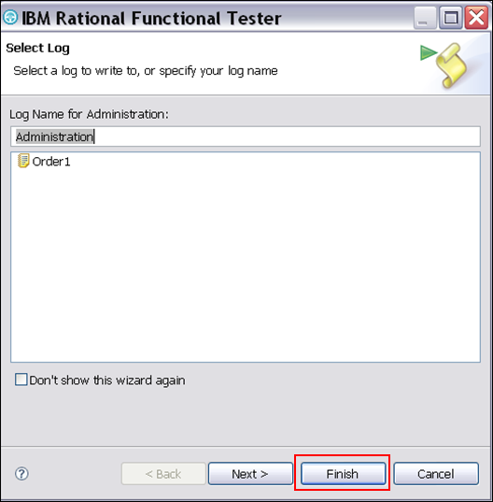
- Do Not touch keyboard test will start playing back
- Review Test Log
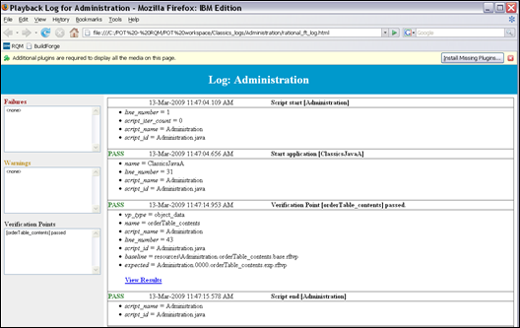
- IBM TechWorks
TechWorks is a worldwide team serving IBM software sales, technical, and development professionals and through these organizations our customers and partners. The TechWorks organization works to:
- Provide implementation, execution, and expertise for brand and general technical sales strategies and objectives
- Provide deep technical and product knowledge directly to customers and partners
- Create material to teach our field teams, our partners, and our customers about what IBM products can do
- Operate world-class, high-quality facilities that support and enhance the interactions between our field technical sales team and our clients and partners
For more information about IBM TechWorks, talk with your IBM sales representative.
- Notices
This information was developed for products and services offered in the U.S.A.
IBM may not offer the products, services, or features discussed in this document in other countries. Consult your local IBM representative for information on the products and services currently available in your area. Any reference to an IBM product, program, or service is not intended to state or imply that only that IBM product, program, or service may be used. Any functionally equivalent product, program, or service that does not infringe any IBM intellectual property right may be used instead. However, it is the user's responsibility to evaluate and verify the operation of any non-IBM product, program, or service.
IBM may have patents or pending patent applications covering subject matter described in this document. The furnishing of this document does not grant you any license to these patents. You can send license inquiries, in writing, to:
IBM Director of Licensing
IBM Corporation
North Castle Drive
Armonk, NY 10504-1785
U.S.A.
For license inquiries regarding double-byte (DBCS) information, contact the IBM Intellectual Property Department in your country or send inquiries, in writing, to:
IBM World Trade Asia Corporation
Licensing
2-31 Roppongi 3-chome, Minato-ku
Tokyo 106-0032, Japan
The following paragraph does not apply to the United Kingdom or any other country where such provisions are inconsistent with local law: INTERNATIONAL BUSINESS MACHINES CORPORATION PROVIDES THIS PUBLICATION "AS IS" WITHOUT WARRANTY OF ANY KIND, EITHER EXPRESS OR IMPLIED, INCLUDING, BUT NOT LIMITED TO, THE IMPLIED WARRANTIES OF NON-INFRINGEMENT, MERCHANTABILITY OR FITNESS FOR A PARTICULAR PURPOSE. Some states do not allow disclaimer of express or implied warranties in certain transactions, therefore, this statement may not apply to you.
This information could include technical inaccuracies or typographical errors. Changes are periodically made to the information herein; these changes will be incorporated in new editions of the publication. IBM may make improvements and/or changes in the product(s) and/or the program(s) described in this publication at any time without notice.
Any references in this information to non-IBM Web sites are provided for convenience only and do not in any manner serve as an endorsement of those Web sites. The materials at those Web sites are not part of the materials for this IBM product and use of those Web sites is at your own risk.
IBM may use or distribute any of the information you supply in any way it believes appropriate without incurring any obligation to you.
Any performance data contained herein was determined in a controlled environment. Therefore, the results obtained in other operating environments may vary significantly. Some measurements may have been made on development-level systems and there is no guarantee that these measurements will be the same on generally available systems. Furthermore, some measurements may have been estimated through extrapolation. Actual results may vary. Users of this document should verify the applicable data for their specific environment.
Information concerning non-IBM products was obtained from the suppliers of those products, their published announcements or other publicly available sources. IBM has not tested those products and cannot confirm the accuracy of performance, compatibility or any other claims related to non-IBM products. Questions on the capabilities of non-IBM products should be addressed to the suppliers of those products.
All statements regarding IBM's future direction and intent are subject to change or withdrawal without notice, and represent goals and objectives only.
This information contains examples of data and reports used in daily business operations. To illustrate them as completely as possible, the examples include the names of individuals, companies, brands, and products. All of these names are fictitious and any similarity to the names and addresses used by an actual business enterprise is entirely coincidental.
COPYRIGHT LICENSE:
This information contains sample application programs in source language, which illustrate programming techniques on various operating platforms. You may copy, modify, and distribute these sample programs in any form without payment to IBM, for the purposes of developing, using, marketing or distributing application programs conforming to the application programming interface for the operating platform for which the sample programs are written. These examples have not been thoroughly tested under all conditions. IBM, therefore, cannot guarantee or imply reliability, serviceability, or function of these programs.
- Trademarks and copyrights
The following terms are trademarks of International Business Machines Corporation in the United States, other countries, or both:
IBM | IBM logo | RequisitePro | Rational | ClearQuest
Java and all Java-based trademarks and logos are trademarks of Sun Microsystems, Inc. in the United States, other countries, or both. See Java Guidelines
Microsoft, Windows, Windows NT, and the Windows logo are trademarks of Microsoft Corporation in the United States, other countries, or both.
Other company, product and service names may be trademarks or service marks of others.

