Lab 2: Searching in Google

Goal: Be able to use basic SWAT commands

Specific objectives
- Use Firebug to identify the names of the Google textbox and search button
- Develop a test that will
  - Set the search term to “Workshop on Integrating Software Testing”
  - Press the Search button
  - Click on an anchor tag that includes ‘fiu’ in the href and ‘Software Testing’ in the innerHTML
  - Ensure that Peter Clarke’s email address is present (clarkep@cis.fiu.edu)

Steps
- Determine the names of the Google textbox and search button
  - Open Firefox
  - Navigate to www.google.com
  - Rightclick on the screen and choose “Inspect Element”
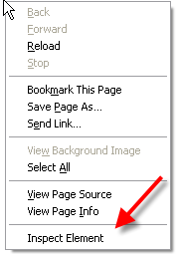
  - Click on Inspect in the new toolbar at the bottom
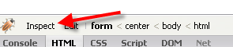
  - As you move your mouse over the browser screen you should now see a blue box
  - Click in the search box
  - At the bottom of the screen the current DOM will be displayed
    - 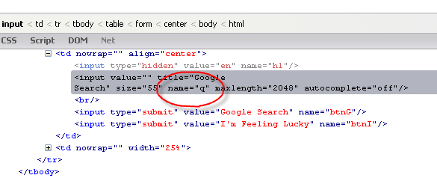
  - Note the name of the text box
  - Repeat steps g-h for the Search button
    - Hint
      - Textbox name = q
      - Search button name = btnG
- Open your fitnesse homepage
- Navigate back to the TestLab
  - Click on the link “TestLab”
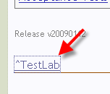
- Click the Edit button
- Add the statements to set the textbox value and click the button
  - Leave a blank line after the last block
  - Create a new Test Block
    - !|SWATFixture|
  - Add the Set Element statement
    - |SetElementAttribute|identifierType|identifier|attributename|attributeValue|tagname|
      - identifierType = Name
      - identifier = q
      - attributeName = value
      - attributeValue = "Workshop on Integrating Software Testing"
      - tagName = Input
  - Add the Stimulate Element statement
    - |StimulateElement|identifierType|identifier|eventName|tagname|
      - identifierType = Name
      - identifier = btnG
      - eventName = onclick
      - tagName = Input
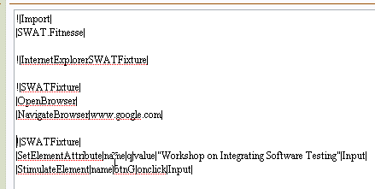
- Add the statements to click on the anchor tag that includes FIU in the href and Software Testing in the innerHTML
  - Leave a blank line after the last block
  - Create a new Test Block
    - !|SWATFixture|
  - Add the Stimulate Element statement
    - |StimulateElement|identifierType|identifier|eventName|tagname|
      - identifierType = Expression
      - identifier = href:fiu;innerHTML:Software Testing
      - eventName = onclick
      - tagName = A
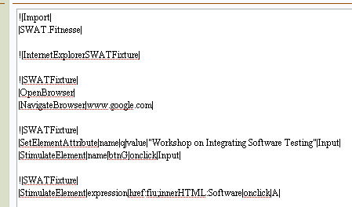
- Add the statements to check for Dr. Clarke’s email address
  - Leave a blank line after the last block
  - Create a new Test Block
    - !|SWATFixture|
  - Add the AssertElementExists Statement
    - |AssertElementExists|identifierType|identifier |tagname|
      - identifierType = Expression
      - identifier = href:clarkep@cis.fiu.edu
      - tagName = A
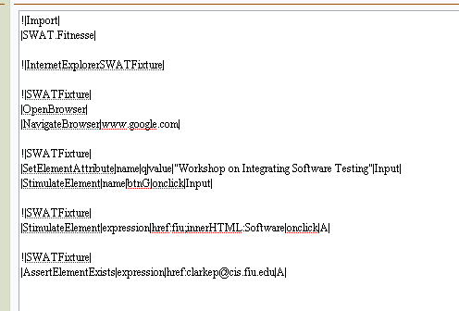
- Click Save
- Click Test

